Dallas May 2010 Sectional Winners
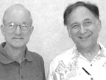 | 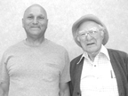 | 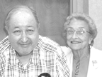
Del Parker, Bill St. Clair  Fri Aft Pairs A | John Cisman, Bob Joyce  Sat Eve Pairs C | Howard Tureff, Ann Roberts  Sat Eve Pairs A
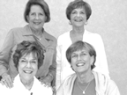 | 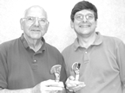 | 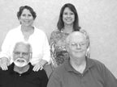
Beth Coker, Emily Leake  Brenda Baker, Nancy Stanton  Sat Eve Swiss A | Eugene, Steve Waller  Sat Eve 499er AB | Joan Jackson, Nancy Passell  Bryan Storey, Tom Edwards  Sat KO I
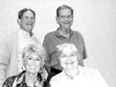 | 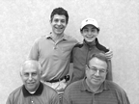 | 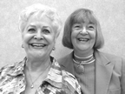
Mark Zeitlin, Gary Corey  Jean Kidd, Nacy Horvat  Sat KO III | Jesse, Elliott Gordon  Scott Mason, Randy Field  Sat KO III | Suzanne Wilson, Linda Scott  Sat Aft 499er B  Sun 499er C
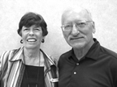 | 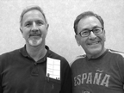 | 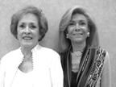
Kay, Dick Schlough  Sat Aft 199er AB | Richard Page, Richard Gordon  Sat Aft 499er Pairs A | Joan Daniel, Jo England  Fri Aft 499er A
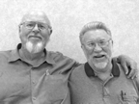 | 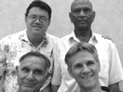 | 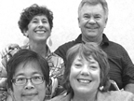
Eve Pairs A Larry Laird, Bill Lease  Fri | David Crooks,Naren Ora  Harry Elliott, Bob Wilkin  Fri Swiss 1-2 B-C | Rebecca Brown, Bob Steidel  Liane Tsai, Susan Hernandez  Fri Eve 1-2 AB Swiss
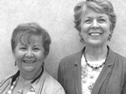 | 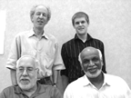 | 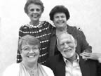
Tommie Antlemyer, Sandy Fedro  Fri Eve 499er A | Bart Bramley, Jeremy Fournier  Ira Chorush, Hamant Lall  Fri Nite Swiss A | Polly Moss, Katie Kowierschae  Nora Oliver, Bob Marum  Thur-Fri KO III
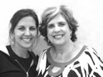 | 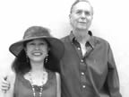 | 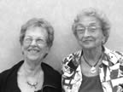
Shannon Castans, Avis Fortado  Fri Aft 199er A-B | Donna, Bill Garrard  Thur B Open Pairs  Fri Nite B Open Pairs | Gerrie Owen, Ann Roberts  Thur Nite Open Pairs
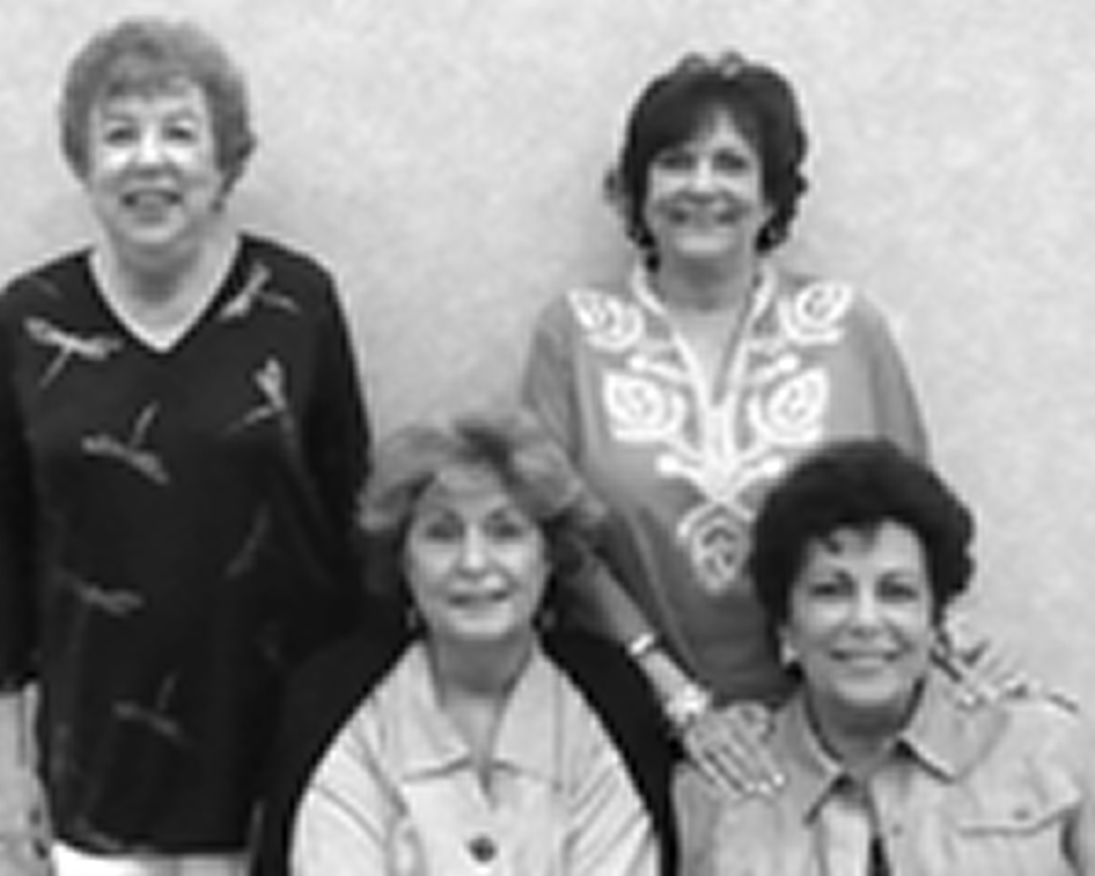 | 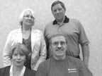 | 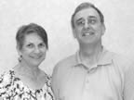
Adrianne Feuer,  Maracia Joy Varel  Lue Waddle, Ann Lewis  Thur-Fri KO II | Ruby Hill, Bob Frisch  Barbara Martikan, Bill Pfeiff  Thur-Fri KO IV | Janet, Bob Smith  Fri 499er C Pairs  Sat Eve 499er C Pairs
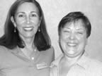 | 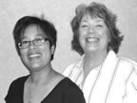 | 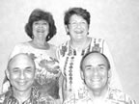
Nancy Fellman, Cheryl Clark  Sun Eve 499er B | Liane Tsai, Susan Hernandez  Sun Open Pairs B | Karen Fillis, Tessa Bodnar  George Fillis, Richard Curtain
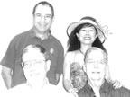 | 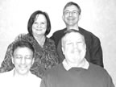 | 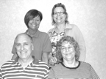
GNT B  David Pearlman, Donna Garrard  Joe Gill, Bill Garrard | Margaret Raymond, Paul Taylor  Robert Scrimale, Jim Harp  Mon Swiss BC | Linda Griffith, Sandy  Mark Heep, Liz Cooper  499 Sun Swiss A
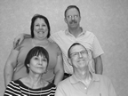 | 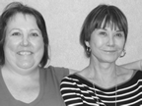 | 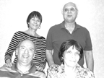
Shawn Quinn, Joe Quinn  Petra Hamman, Phillip Grothus  Sat Compact KO A | Swawn Quinn, Petra Hamman  Mon Swiss A | Petra Hamman, John Sutherlin  Nagy Kamel, Peggy Sutherlin  Thu-Fri KO I
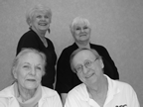 | 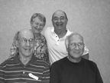 | 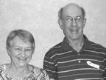
Nancy Boothe, Bennie Rienstra  Peggy Thomas, Stan Carr  Mon 499 Swiss B | Kathy Aten, Rich Brandenburg  Beach Aten, Max Frey  Mon Swiss D | Kathy, Beach Aten  Sun Eve 499er A
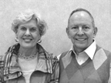 | 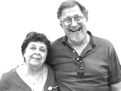 | 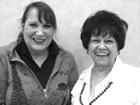
Jeanine Wofford, David Nurenberg  Sat Morn Pairs AB | Sue Kay Reeder, George Morey  Sat Morn 199er ABC | Catherine Tucker, Dorsey Shaw  Sat Aft Pairs AB
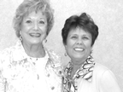 | 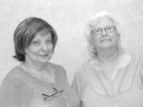 | 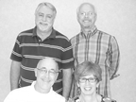
Phyllis Savell, Bonnie Shea  Sat Eve Pairs B | Carlene Eddlemon, Jo Basel  Sun 499er B | Steve Hibbard, Mickey Tryon  Jim Hibbard, Lauren Brown  Sun Compact KO II

