Dallas Sectional March 2013
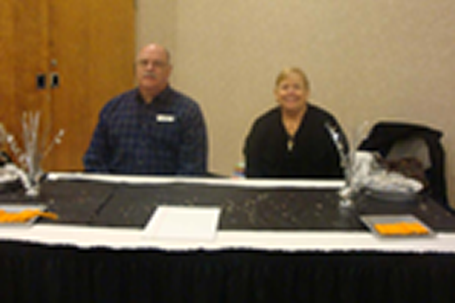 | 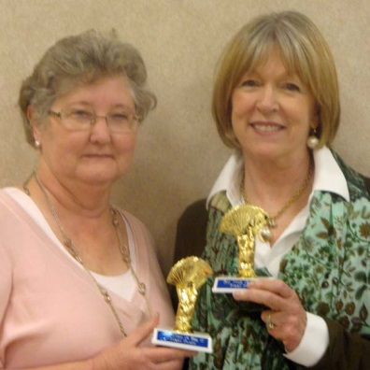 | 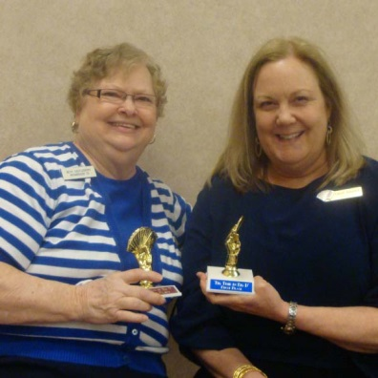
Gelles at Hospitality Table | Thurs AM 49er Prs A Anne Curry & Jeanne Wyatt | Thurs AM 299er Prs ABC Beth Castleberry & Carol Adamek
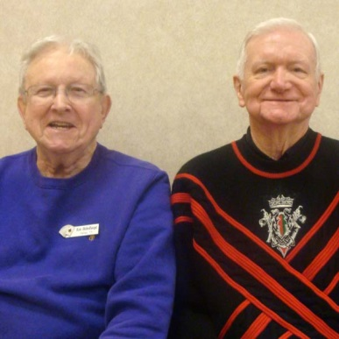 | 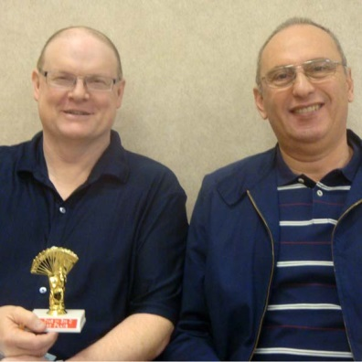 | 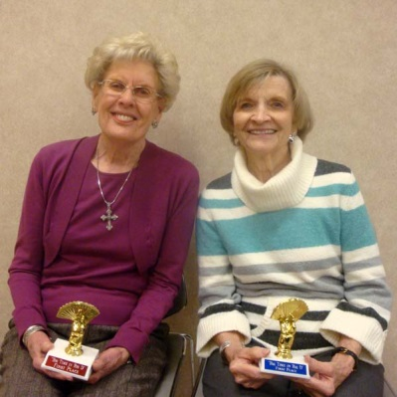
Thurs AM 1500er Prs AB Ken Bickelhaupt & John Jackson | Thurs AM Open Prs A Mark Bumgardner & Nagy Kamel | Thurs AM Open Prs B Jeanine Wofford & Barbara Nelson
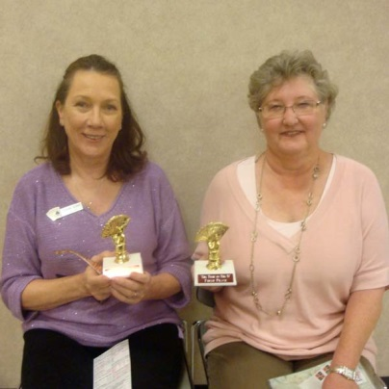 | 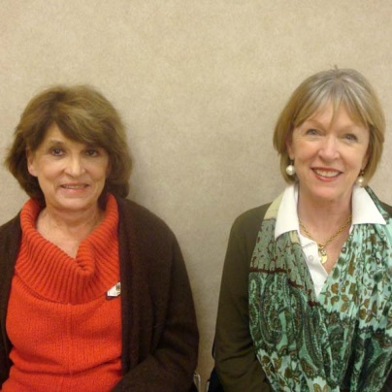 | 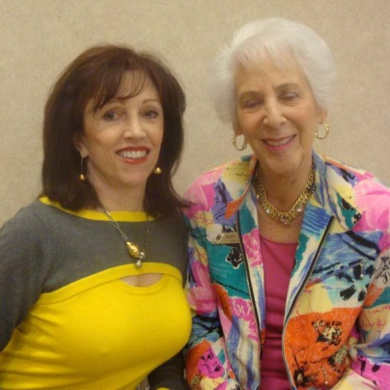
Thurs Aft 49er Prs A Chris Skibell & Anne Curry | Thurs Aft 49er Prs B Linda Robertson & Jeanne Wyatt | Thurs Aft 299er Prs C Fri Morn 299er Prs ABC Fritzie Roop & Janet Meyer
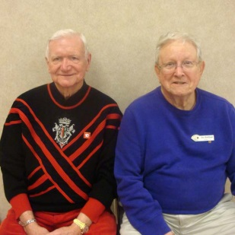 | 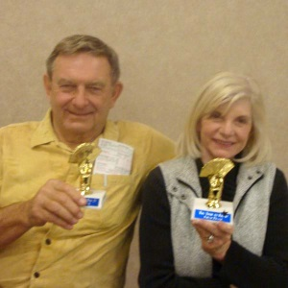 | 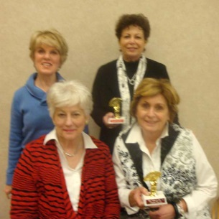
Thurs Aft 1500er Prs AB John Jackson & Ken BickelhauptA/B/C | Thurs Aft & Thurs Eve 299er Prs A Charles & Pat BrionA, Sat. Aft. Open Flt A | Thurs Compact KO Teams Bkt 1 Ann Lewis & Nancy Harralson Adele Hudgins & Lue WaddleOpen B
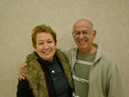 | 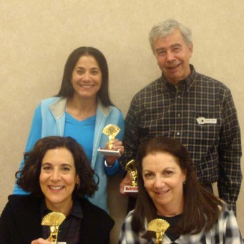 | 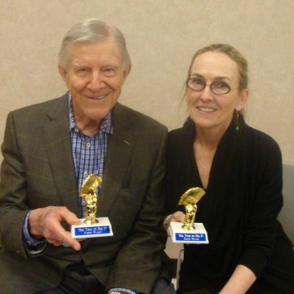
Elaine & Joseph Bindo, Thurs Eve 499er A/B | Thurs Compact KO Teams Bkt 2 Ruthie Shor & Randy Earle Susan Bates & Beverly Strauss | Thurs Eve 299er Prs B John & Annie Mason
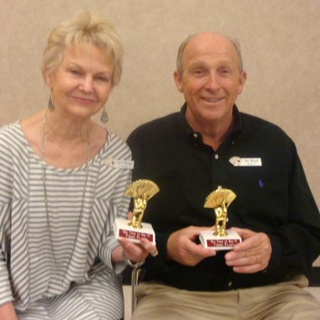 | 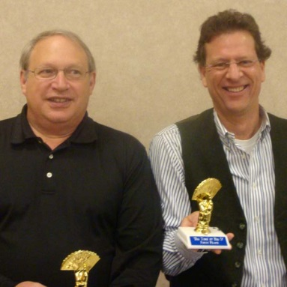 | 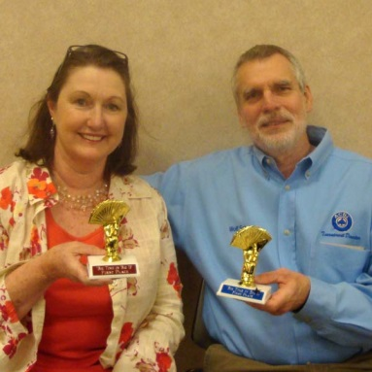
Thurs Eve 299er Prs C 123 Carol Morgan & James Meade | Thurs Eve 299er Prs C123 Will Snyder & Fred Seipp | Thurs Eve Open Prs B Kathy Bumgardner & Wolf Schroeter
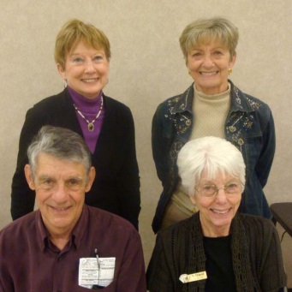 | 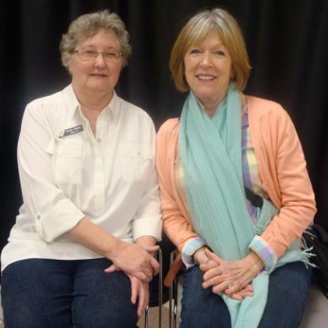 | 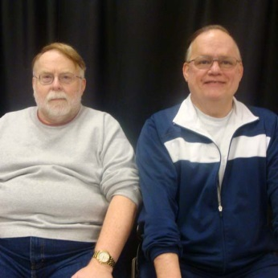
Thurs KO Bkt 2 Jean ONeal & Gay Schleicher Terry Wolfe & Jo Driscoll | Fri Morn 49er Prs A Anne Curry & Jeanne Wyatt | Fri Morn 1500er Prs ABC Terry Tankersley & Ramon Nelson
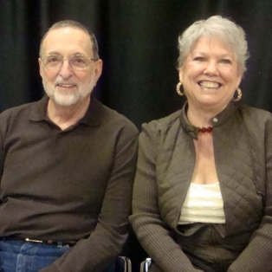 | 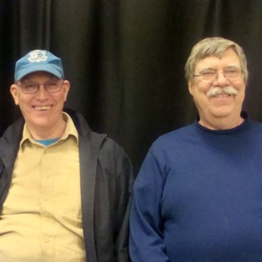 | 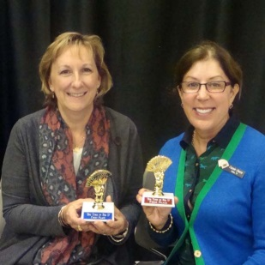
Fri Morn Open Prs A Jim Bauer & Judy Northup | Fri Morn Open Prs B Michael Hout & Gerry McKim KO, Bracket 2 | Fri Aft 49er Prs AB Anne Difiore & Cassie Stern
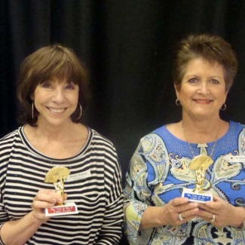 | 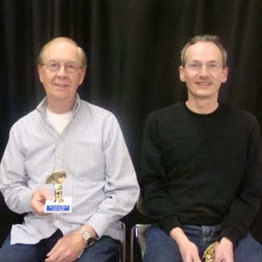 | 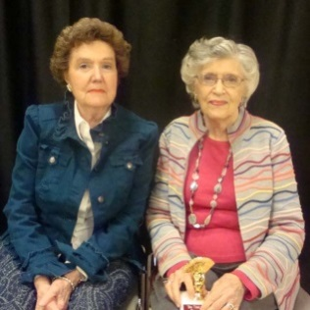
Fri Aft 299er Prs ABC Karen Roland & Patsy Rainwater Maddu | Fri Aft 1500er Prs ABC Patrick Keating & Christian Remling | Fri Aft Open Prs C June Barnebey & Ruth Wiener
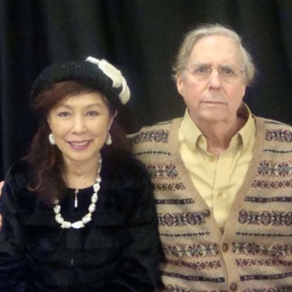 | 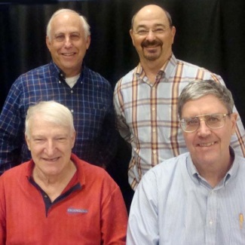 | 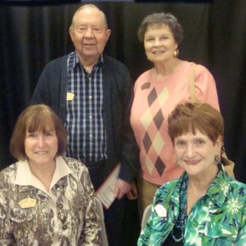
Fri Aft Open Prs Donna & William Garrard | Fri Bkted KO Teams Bkt 1 Scott Nason & Rich Brandenburg Tony Pellegrini & Joseph Gill | Fri Bkted KO Teams Bkt 2 Melvin Ball & Gay Nell Ball Dee Norris & Betty Peterson
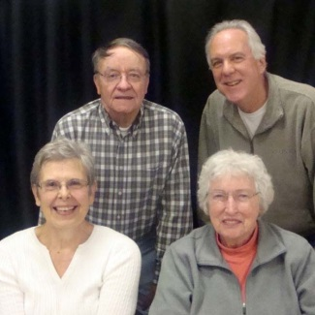 | 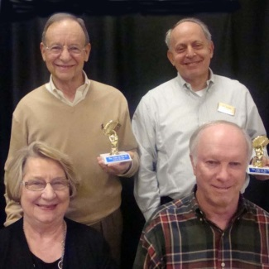 | 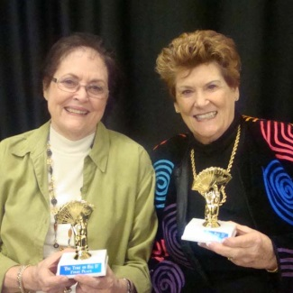
Fri Compact KO Teams Bkt 1 Billy Leeper & Robert Buchanan Pat Cassidy & Mary Orock | Fri Compact KO Teams Bkt 2 Bruce Harbour & Stephen Birnbaum Penny Hawkins & Bob Butterfield | Fri Eve 49er Prs AB Caroline Drews & Judith Latham
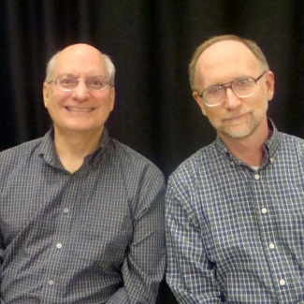 | 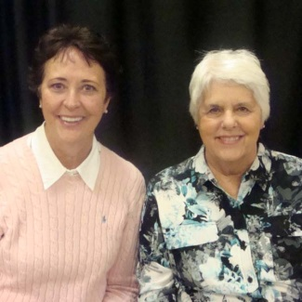 | 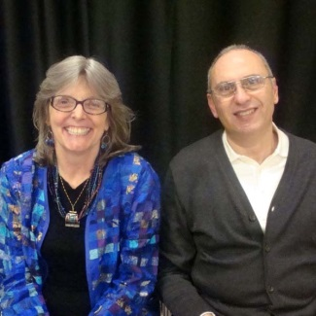
Fri Eve 299er Prs AB John Blacklock & Edward Boenker | Fri Eve 299er Prs C Barbara Smith & Connie Lowry | Fri Eve Open Prs 12 Merri Jo Hillaker & Nagy Kamel
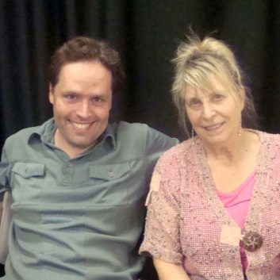 | 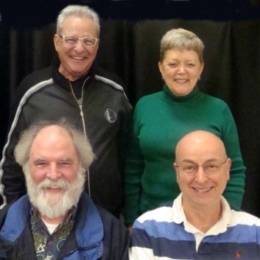 | 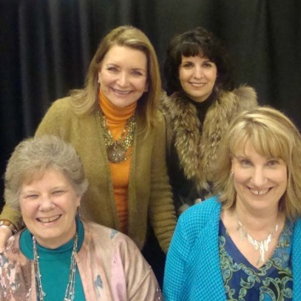
Fri Eve Open Prs A 12 Jason Larrivee & Pamela Keim | Fri Eve Swiss A Barry Schaffer & Nancy Kornegay Hugh Hillaker & Stephen Kornegay | Fri Eve Swiss C Susan Keyes & Marjorie Deutsch EJ Nowak & Therese Milford
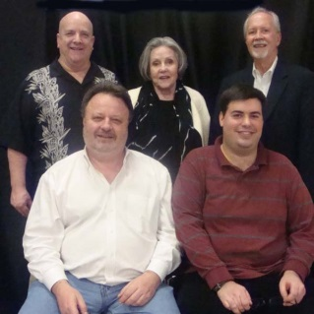 | 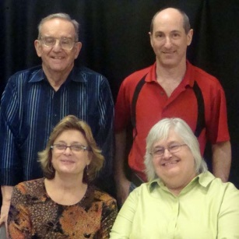 | 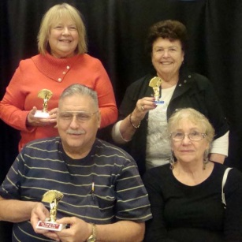
Thurs Bkted KO Teams Bkt 1 Curtis Cheek, Susan Key, Tom Breed Chris Compton & David Grainger | Thurs Eve Swiss A Jay Gibson & Eric Diamond Martha Young & Judy Lotridge | Thurs Eve Swiss B Lynda Bradley & Katye Kowierschke James Cothran & Ruby Hill
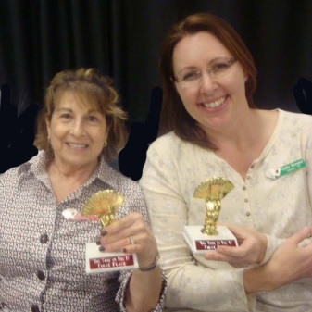 | 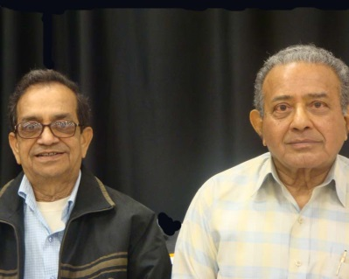 | 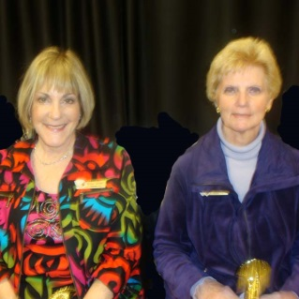
Sat Morn 49er Prs AB Evelyn Dashefsky & Cathy Ranspot | Sat Morn 299er Prs Venkata Vishnubholta & Satish Shah | Sat Morn 1500er Prs ABC May Sebel & Nancy Kelly
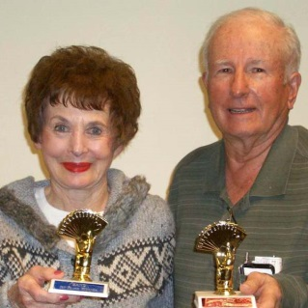 | 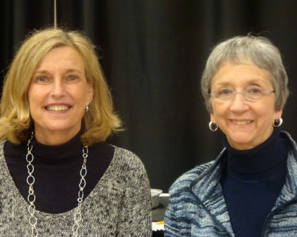 | 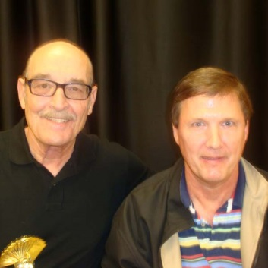
Sat Morn Open Prs A Gail Wells & Marion Gebhardt | Sat Morn Open Prs B Nancy Stanton & Lynn Wood | Sat Aft 49er Prs Robert Terry & Jeffrey Smith
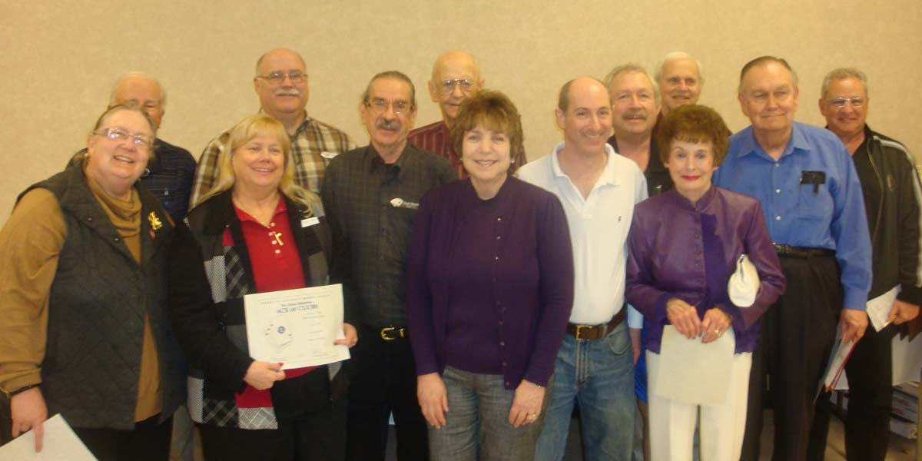
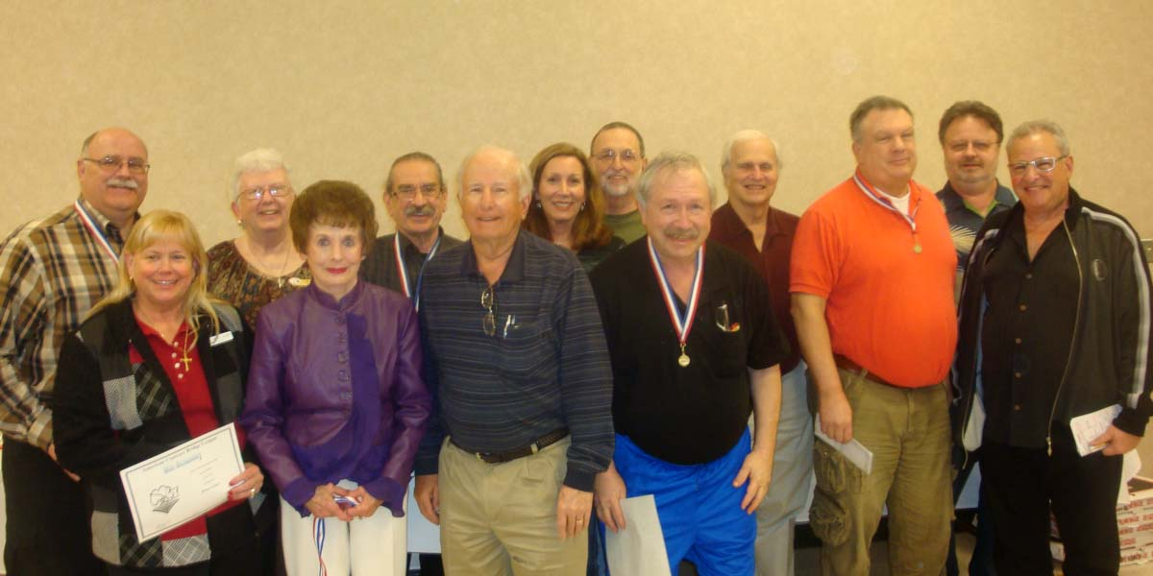
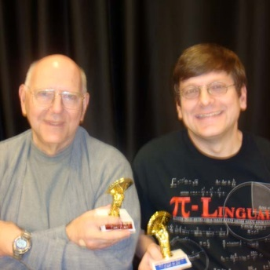 | 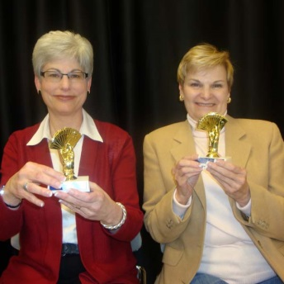 | 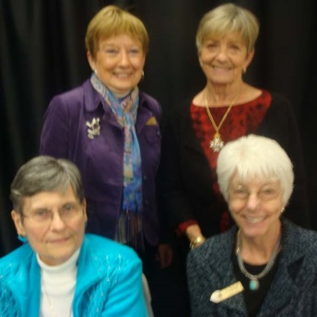
Sat Aft 299er Prs A Eugene Wuller & Stephen Wuller | Sat Aft 1500er Prs A Susan Flick & Jackie Hertweck | Sat Bkted KO Teams Bkt 4 Jean ONeal & Gay Schleicher Nancy Jipp & Jo Driscol
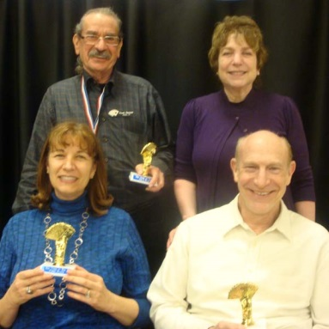 | 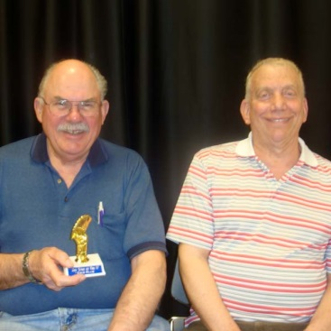 | 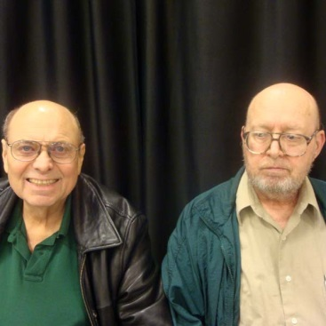
Sat Eve Swiss Teams C Frank Durante & Lynn Cooper Nancy Latner & Barry Cooper | Sat Morn Open Prs C Lee Huber & Mark Hatkoff | Thurs Aft Open Prs A Robert Adams & David Foote
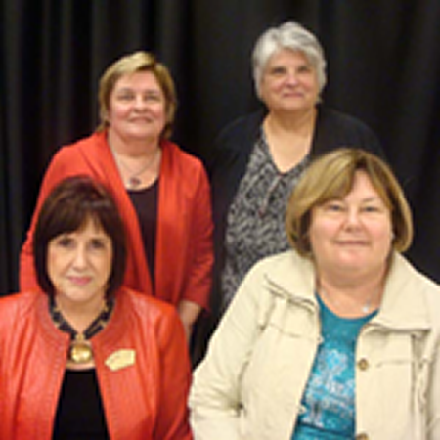 | 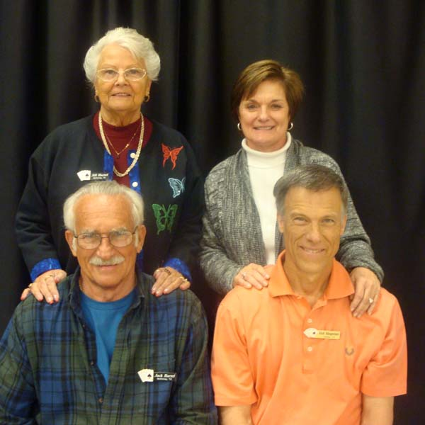 | 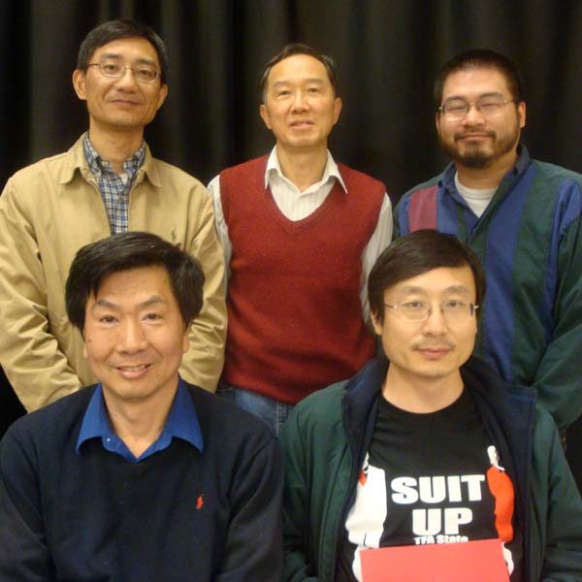
Sun Aft 299er Swiss A Diane Segel & Jenny Oswald Carol Bice & Sandy Brown | Sun Morn 299er Swiss ABC Sun Aft 299er Swiss BC Jill Hartel & Leah Margerison John Hartel & Rick Margerison | Sun Strati-Flted Swiss X Hanchang Wang, Tiger King, Hank Eng Hua Yang & Edward Wang
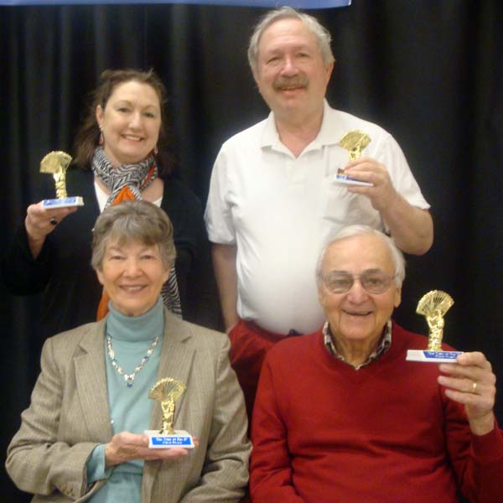 | 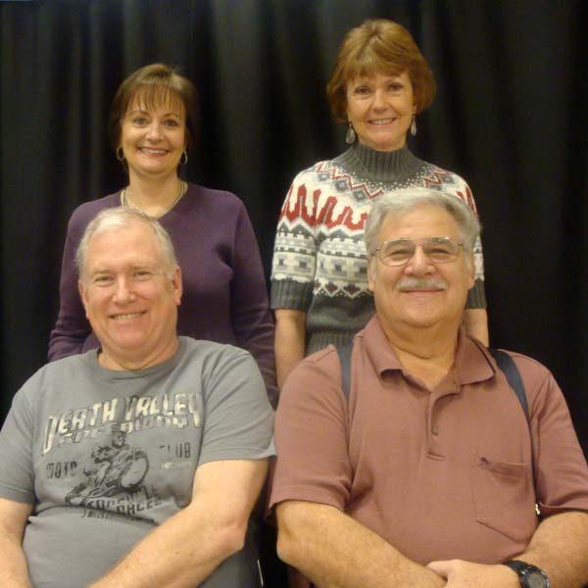 | 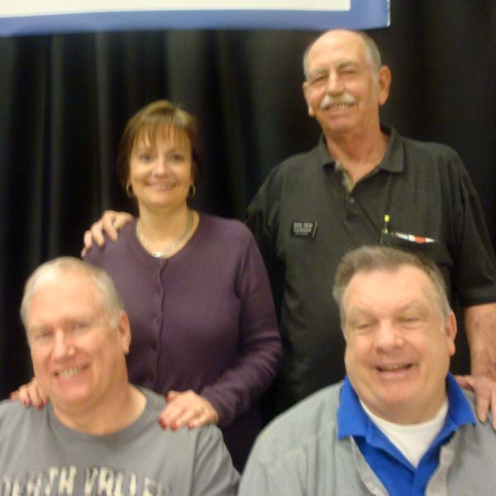
Sat Compact Ko Teams Bkt 2 Kathy Bumgardner & Jerry Albom Elinor Fries & Joe Fletcher | Fri Eve Swiss Teams C Mary Ann White & Becky Koenigseder Jimmy Reynolds & Gary Neisler | Sat Bkted KO Bkt 2 Mary Ann White & Jack Killough Jimmy Reynolds & Jim Harp

