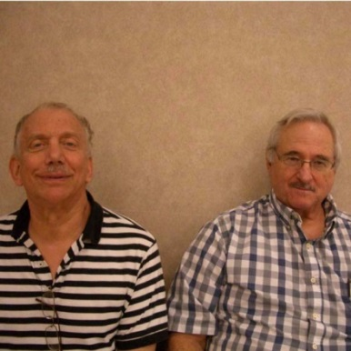

Thursday Morning Open Prs A
Mark Hatkoff & Royce McCray

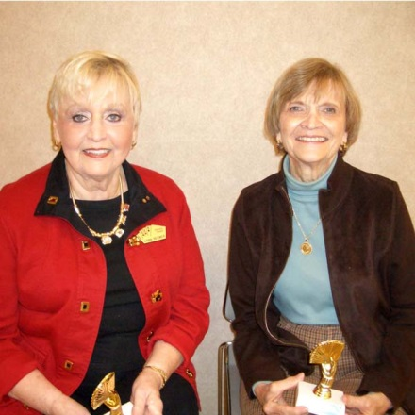

Thursday Morning Open Prs B
Barbara Nelson & Lynn Belmer

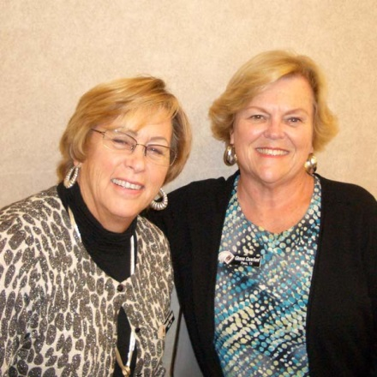

Thursday Morning 49er Prs
Veronica Vokolek & Glenna Crawford

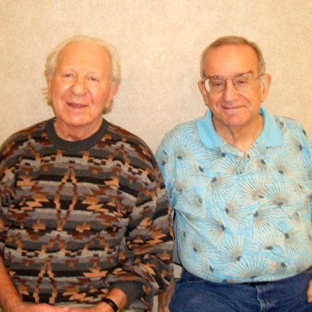

Thursday Afternoon Open Prs A
Leonard Schaen & Jay Gibson

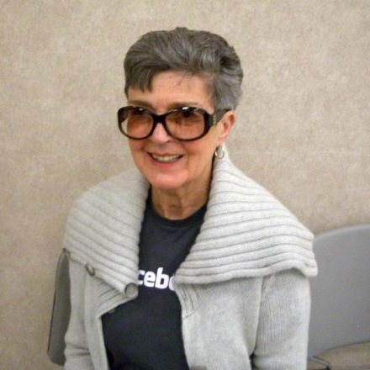

Thurs Aft Open Prs BC
Vi Ganeles & (Np) Mary McGinnis

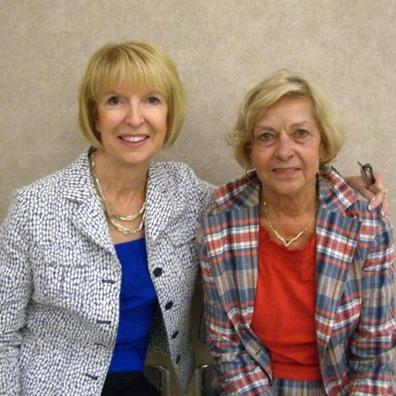

Thurs Aft 299er Prs ABC
Pat Graham & Jo Anne Crandall

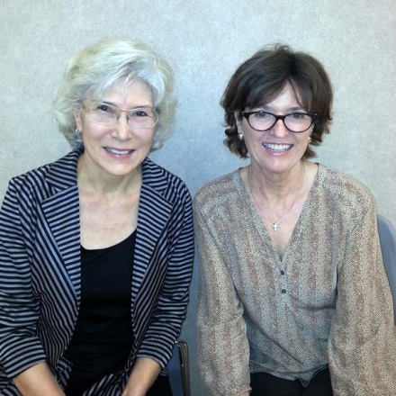

Thurs Aft 49er Prs
Susan Kroney & Barbara Ching

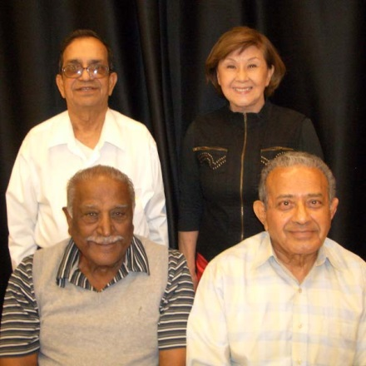

Thurs Bkted KO Teams Bkt 2
Venkata Vishnubhotla & Diana Chen
Rathnam Vasanthkumar & Satish Shah

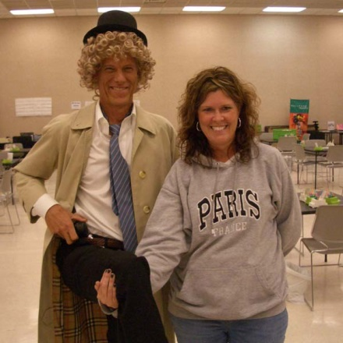

Halloween Costume Winner
Rick Margerison AKA Harpo Marx

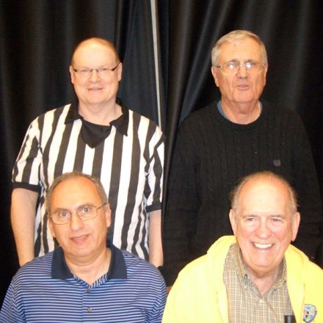

Thurs Bkted KO Teams Bkt 1
Mark Bumgardner & Bill Staats
Nagy Kamel & Dan Morse

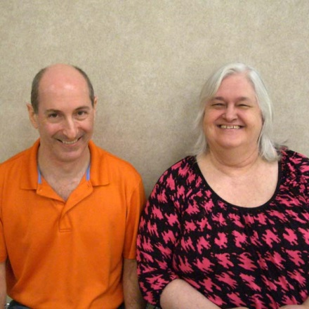

Thurs Eve Open Prs
Eric Diamond & Judy Lotridge

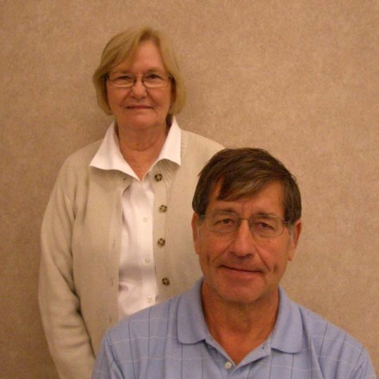

Fri Morn 49er Prs
Ronald Kunkel & Rita Scott

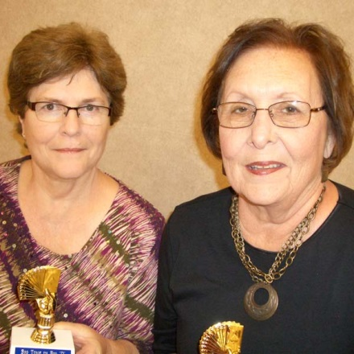

Fri Morn 299er Prs ABC
Sandra Levin & Mary Ellen Little

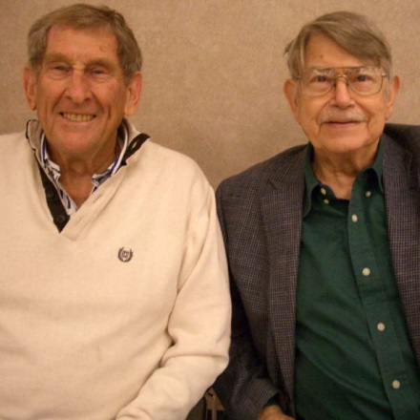

Fri Morn Open Prs A
Earnest Wyatt & Britain Beezley

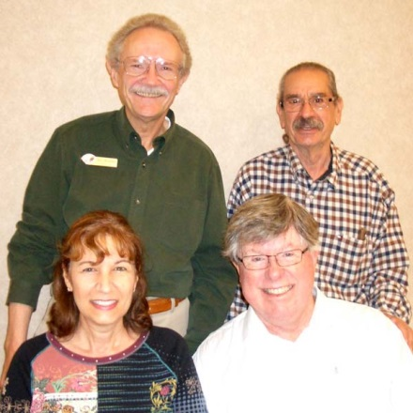

Thurs Eve Swiss BC 1/2
Jerr Boschee & Frank Durante
Nancy Latner & William Olds

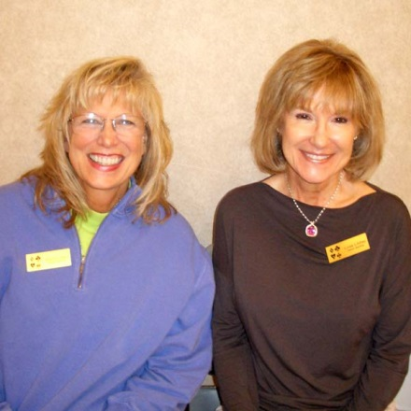

Fri Aft 49er Prs
Linda Lindley & Martha Ward

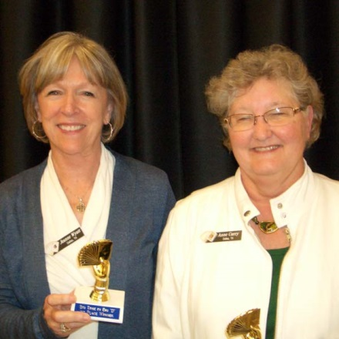

Fri Aft 299er 1/2
Jeanne Wyatt & Anne Curry

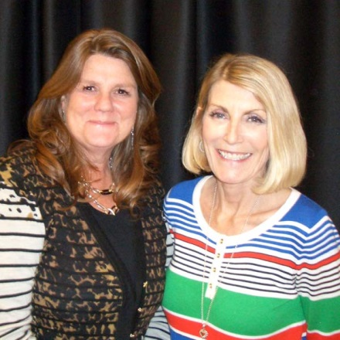

Fri Aft 299er Prs 1/2
Deborah Armstrong & Sharon Ward

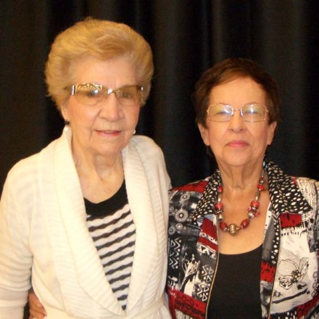

Fri Aft Open Prs A
Larue Stott & Gerrie Owen

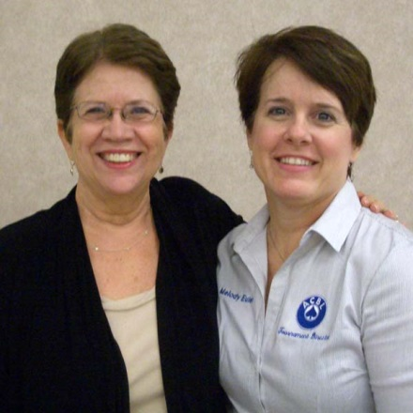

Fri Morn Open Prs B
Tomi Fitzgerald & Melody Euler

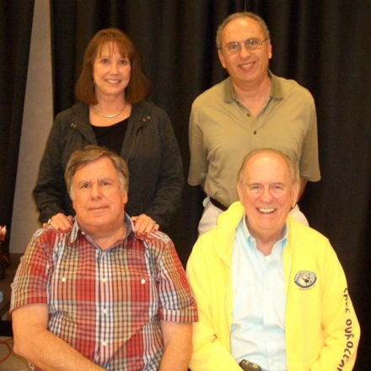

Fri Bkted KO Teams Bkt 1
Nancy Passell & Nagy Kamel
Mike Passell & Dan Morse

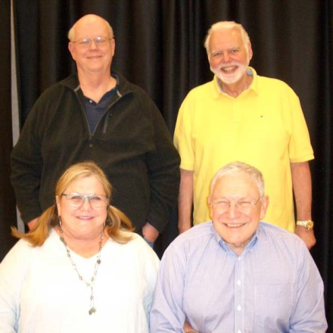

Bkted KO Bkt 1
Tom Edwards & Bryan Storey
Beth & John Bromberg

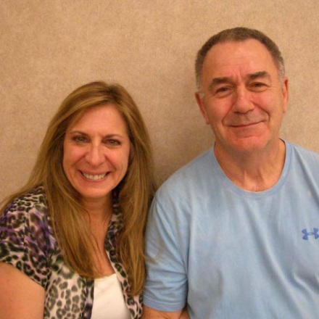

Fri Aft Open Prs B
Elaine Wood & Bachman Nabors

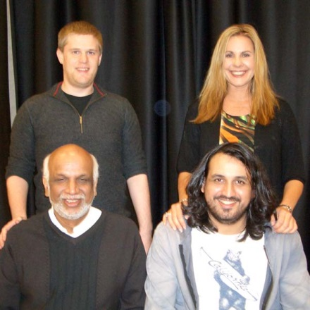

Thurs Eve Swiss Teams A
Jeremy Fournier & Stefanie Scott
Hemant Lall & Justin Lall

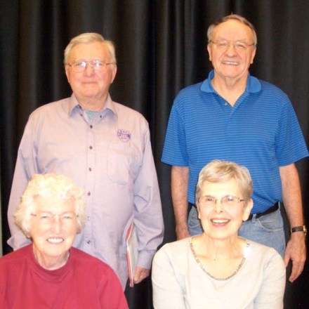

Fri Eve Swiss A 1/2
Jerry Derby & Billy Leeper
Mary Orock & Pat Cassidy

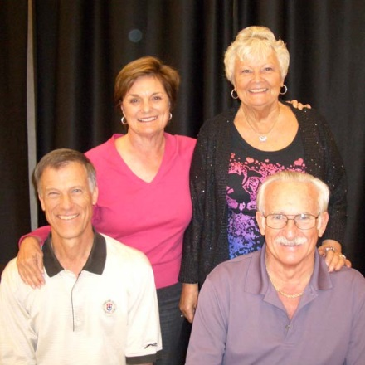

Fri Eve Swiss C
Leah Margerison & Jill Hartel
Rick Margerison & John Hartel

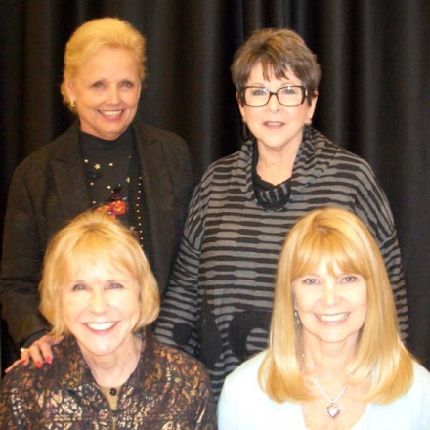

Fri Brkted KO Teams Bkt 2
Beverly Laster & Barbara Horowitz
Shelley Early & Dee Bridgewater

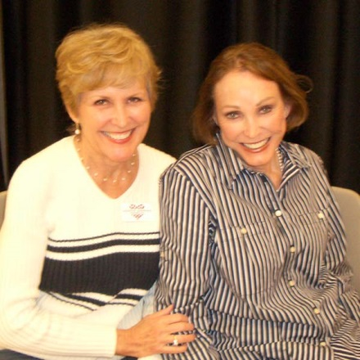

Fri Eve 1500er Prs ABC
Jeanette McDonald & Judy Nixon

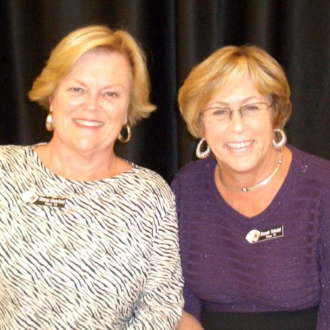

Sat Morn 49er Prs AB
Glenna Crawford & Veronica Vokolek

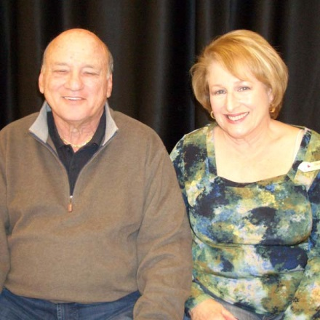

Sat Morn 299er Prs ABC
Michael & Elaine Lowenkron

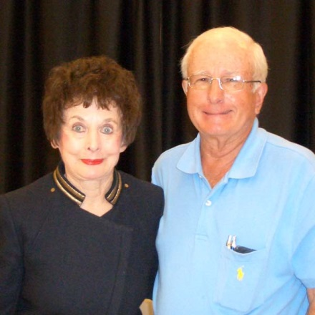

Sat Morn Open Prs A
Gail Wells & Marion Gebhardt

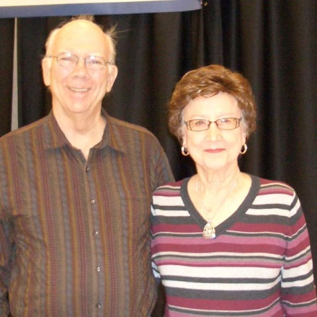

Fri Aft 1500er Prs A
John Davis & Bert Dempsey

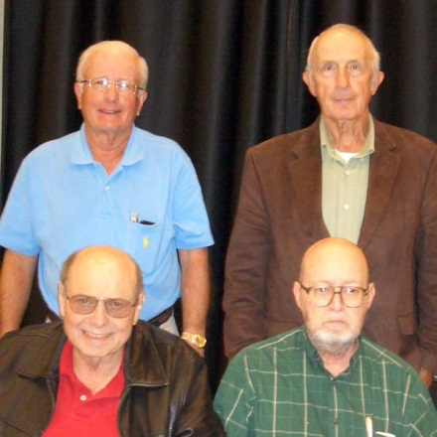

Thurs Cmpt Bkted KO Bkt 1 & Sat Evening Swiss
Marion Gebhardt & Roy Baughman
Bob Adams & David Foote

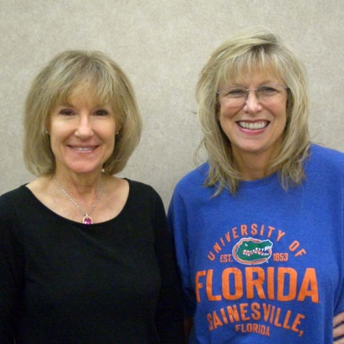

Sat Aft 49er Prs
Linda Lindley & Martha Ward

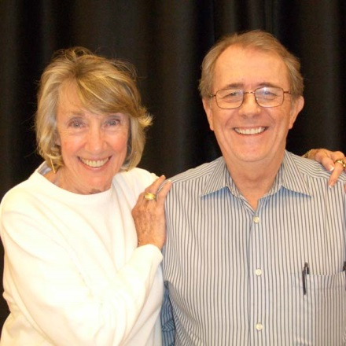

Fri Eve Open Prs B
Eileen Smith & James McCommons

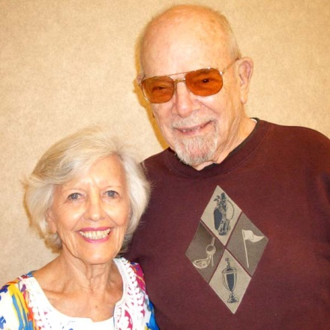

Sat Aft 299er Prs ABC
Jan Choyce & John Gilbert

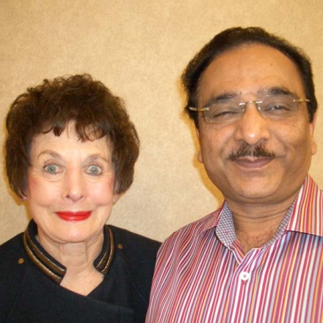

Sat Aft Open Prs A
Gail Wells & Suresh Agrawal

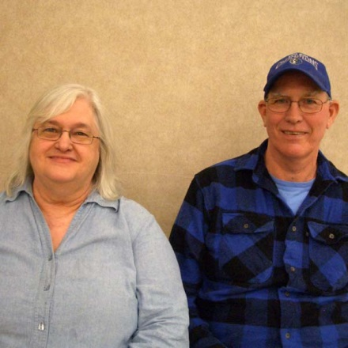

Sat Aft Open Prs B
Judy Lotridge & Michael Hout

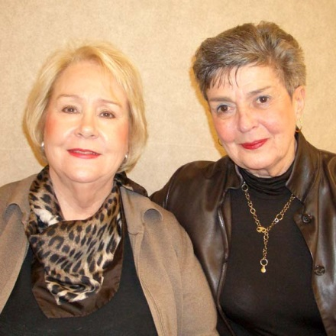

Sat Aft 1500er Prs A
Mary McGinnis & Vi Ganeles

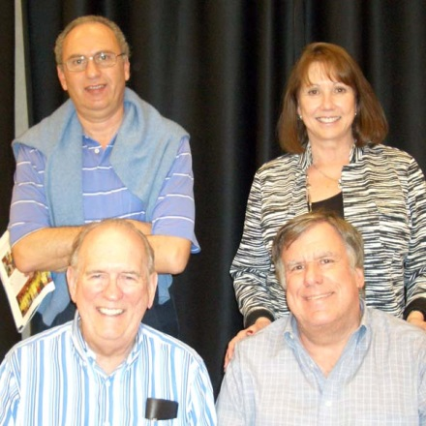

Sat Cmpt Brkt KO Bkt 1
Nagy Kamel & Nancy Passell
Dan Morse & Mike Passell

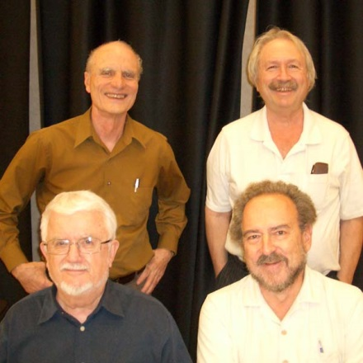

Thurs & Fri Cmpt Bkrt KO Bkt 2
Clint Schuhmacher & Jerrold Albom
Hal DeShong & James Richman

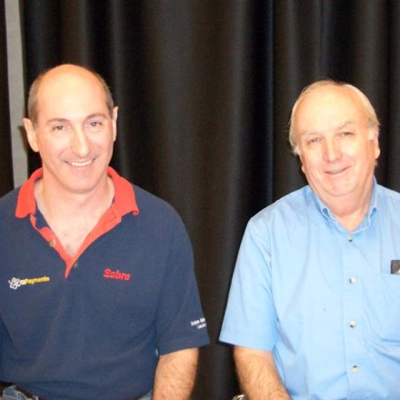

Sat Open Prs A
Eric Diamond & Bob Fritz

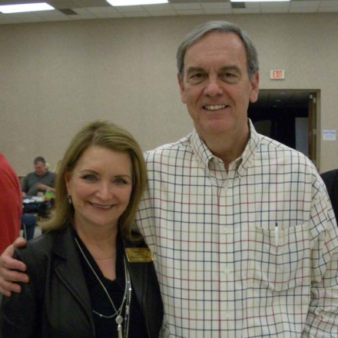

New Life Master Susan Keyes
with her supportive husband Brian

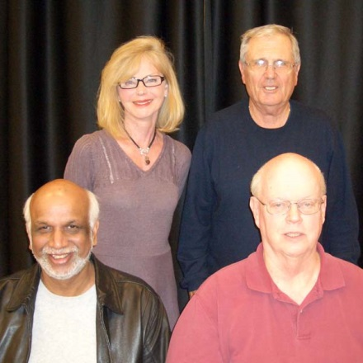

Sat Brkted KO Teams Bkt 1
Emily Harrell & Bill Staats
Hemant Lall & Tom Edwards

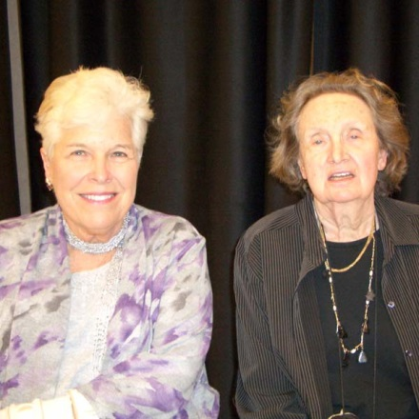

Sun Aft Open Prs A
Mary Lynn Trentham & S Perutz

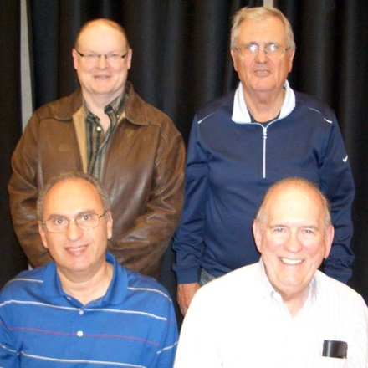

Sun AX Swiss Teams A
Mark Bumgardner & Bill Staats
Nagy Kamel & Dan Morse

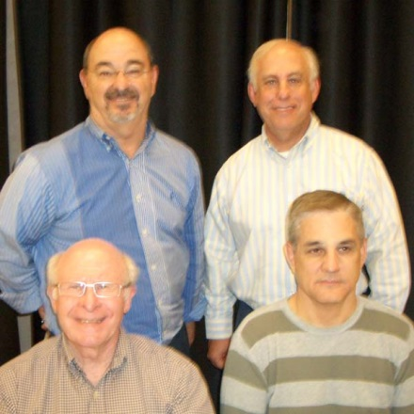

Sun BCD Swiss Teams B
Rich Brandenburg & Scott Nason
Bob McNeill & Jeff Dater

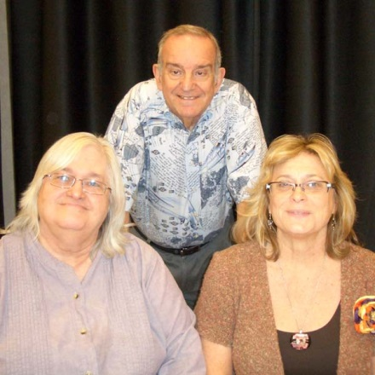

Sun AX Swiss Teams X
Jay Gibson & (np) Eric Diamond
Judy Lotridge & Martha Young

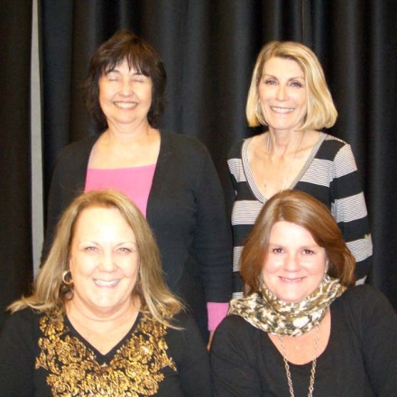

Sun Morn 299er Swiss Teams AB
Constance Vecellio & Sharon Ward
Carol Adamek & Deborah Armstrong

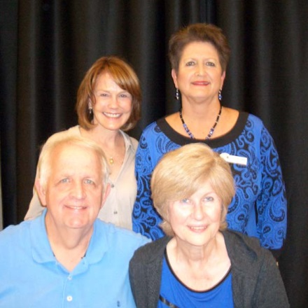

Sun Aft 299er Swiss Teams A
Jill Thompson & Patsy Rainwater
Dan & Betty Woodward

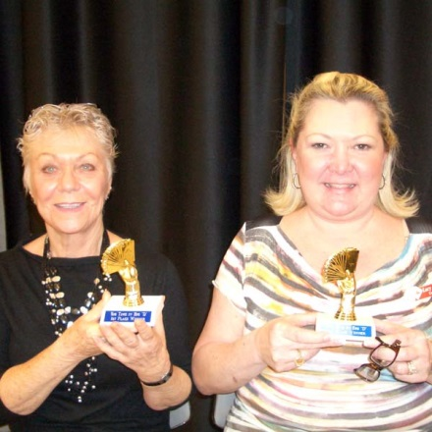

Sun Aft 49er Prs
Carolyn Baker & Lacy Peterson

