2012 BAND 299er Pictures & Results
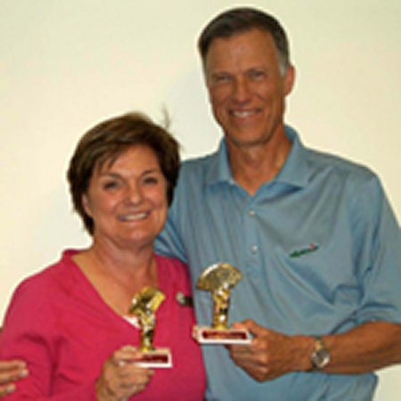 | 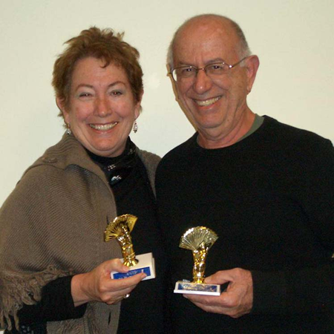 | 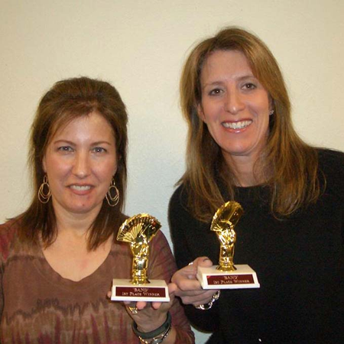 | 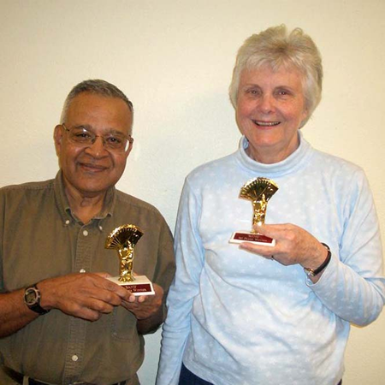
Fri Morn 299er Prs AB Leah & Rick Margerison | Fri Morn 299er Prs C  Elaine & Joseph Bindo | Fri Morn 0-20 Prs  Elise Sher Caryn Jacobs | Fri Aft 299er Prs ABC_  Sv Ramarathnam & Joyce Hahn
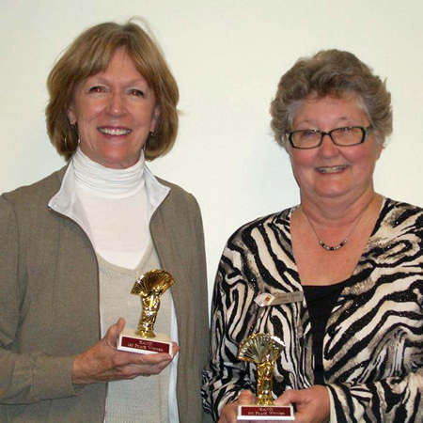 | 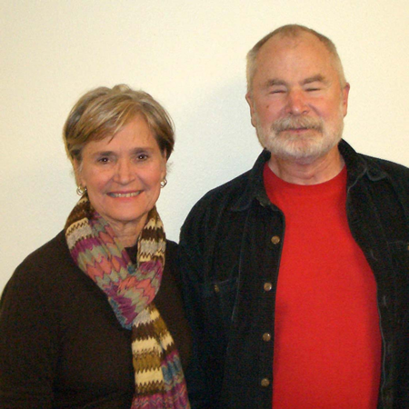
Fri Aft 0-20 Prs  Jeanne Wyatt & Anne Curry | Fri Eve 299er Prs A  Scott & Judy Etchison | Fri Eve 299er Prs BC_  Sv Ramarathnam & Joyce Hahn

